Bryce Draisey Memorial
Golf Tournament
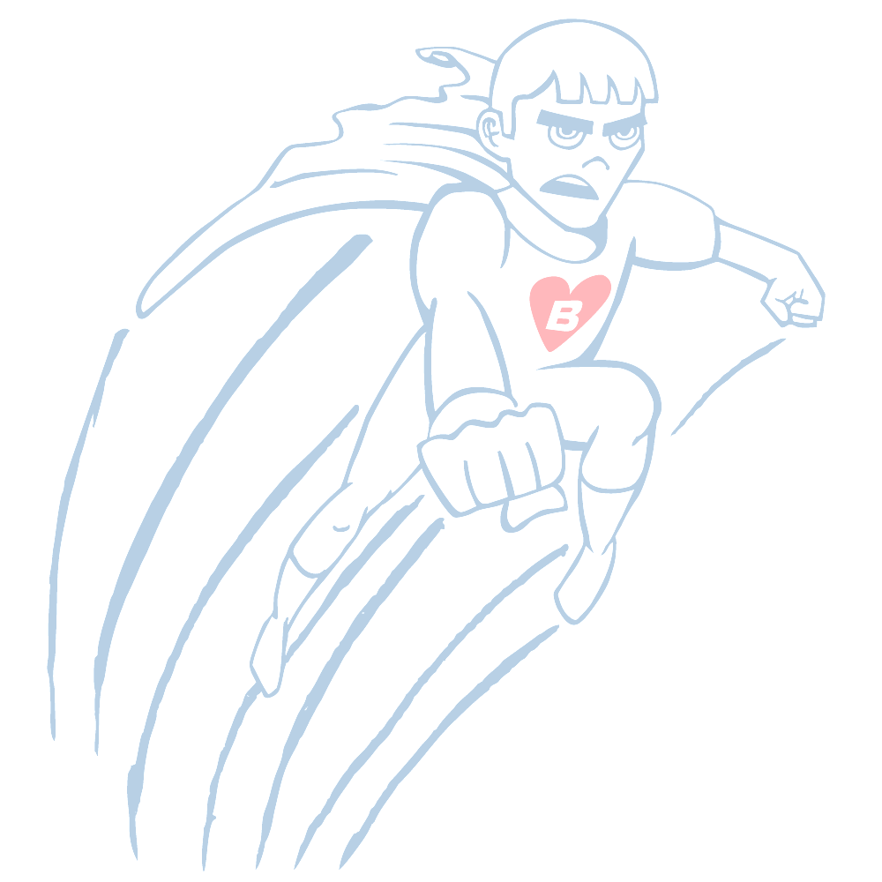
You are invited to play in the 5th Annual Bryce Draisey Memorial golf tournament. This tournament is to raise funds for Bryce’s Warriors, Inc. The foundation will be donating money to the Bryce Draisey Memorial Dollars for Scholars scholarship fund, families of children waiting for and who have had heart transplants, Children’s Miracle Network, and Iowa Donor Network. Scholarships go to students in the SE Polk School District where Bryce was a student. While Bryce lived in and out of the hospital for three years, Children’s Miracle Network provided him with daily distractions which would not be possible without continued fundraising. Iowa Donor Network found the heart that he received via transplant that gave us an extra two years with our son that we would not have otherwise had. We look forward to seeing you all there and thank you for helping to keep Bryce’s memory alive. Check out Bryce’s story at http://www.youtube.com/watch?v=AYNt3jIZod4 and www.carepages.com, Carepage name: BryceDraisey.
Smokey D’s is donating a fantastic meal for everyone after the tournament.
Date: Saturday, September 30, 2017 Team sign up
Registration: 12:00 PM
Start Time: 1:00 PM shotgun (rain or shine) ________________________________
Hole sponsorship: $200 ________________________________
Cost Per Person to play: $50.00(tax deductable) ________________________________
Included: 18 holes golf, cart, and meal ________________________________
Format: 4 Person Best Ball
Place: Terrace Hills Golf Course 8700 NE 46th Ave, Altoona, IA 50009 515-967-2932.

Please make checks payable to Bryce’s Warriors and mail no later than September 13, 2017 to:
Bryce’s Warriors, Inc., PO Box 57381, Des Moines, IA 50317
For questions please contact Derek Draisey at 515-564-9524 or email at dwd2005@msn.com or bryceswarriors@gmail.com.

